1a:prompt generation
Introducing the Nexus Scribe: The AI-Powered Living Notebook
The Nexus Scribe isn't just a place to store your thoughts—it’s an intelligent collaborator designed to bridge the gap between messy handwriting and actionable digital data. Whether you are a student capturing a rapid-fire lecture or a professional managing high-stakes project requirements, the Nexus Scribe adapts to your workflow in real-time.

Core Intelligent Features
- Dynamic Semantic Navigation: Forget endless scrolling. Our AI indexes your notes as you write. Simply search for "that marketing idea from last Tuesday" or "organic chemistry formulas," and the Scribe jumps to the exact stroke on the page.
- Auto-Generating Table of Contents: The notebook automatically categorizes your entries. It detects transitions between subjects and creates a live, clickable Contents Dashboard that updates every time you close the cover.
- Contextual Content Selection: Using Smart-Select AI, you can circle any portion of your notes to trigger specific actions:
  - Professional: Transform meeting scribbles into a polished email draft or a Jira ticket.
  - Student: Convert a diagram into a flashcard or solve a handwritten math equation instantly.
- Haptic Feedback & OCR: High-fidelity Optical Character Recognition (OCR) converts your unique handwriting into searchable text in over 30 languages, maintaining the original layout and formatting.

Designed for Your High-Speed Life
We’ve stripped away the friction of traditional digital note-taking to ensure the Nexus Scribe is as intuitive as paper but as powerful as a workstation.
Feature | For the Student | For the Professional
Accessibility | Instant sync to Canvas, Blackboard, and Notion. | Seamless integration with Outlook, Slack, and MS Teams.
Organization | Auto-tags notes by "Course Code" or "Exam Date." | Categorizes by "Client," "Project," or "Action Item."
Battery & Build | 30-day battery life; built to survive a cramped backpack. | Sleek, executive aesthetic with biometric security locking.

1b: prompt analysis:
zero shot:
To solve this problem, we can break it down into two simple steps:
- Calculate the total number of pencils: Since there are 5 boxes and each box contains 9 pencils, we multiply the number of boxes by the number of pencils per box.
$$5 \times 9 = 45 \text{ pencils}$$
- Calculate the remaining pencils:
Subtract the number of pencils given away from the total number of pencils.
$$45 - 12 = 33 \text{ pencils}$$
Final Answer:
There are 33 pencils remaining.

One shot:

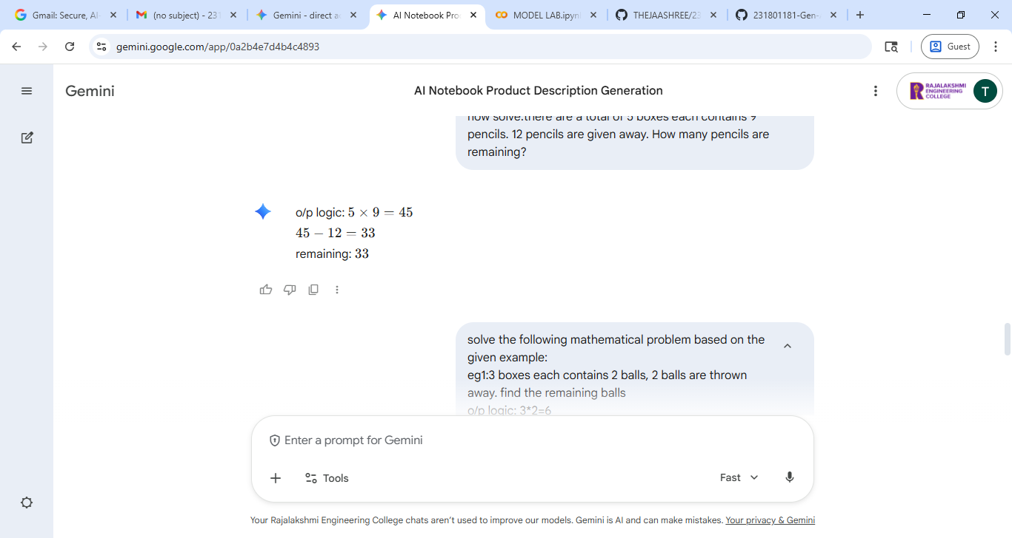

Few shot:


Cot:

